**Light house score for the SpaceX project hosted website in Heroku**

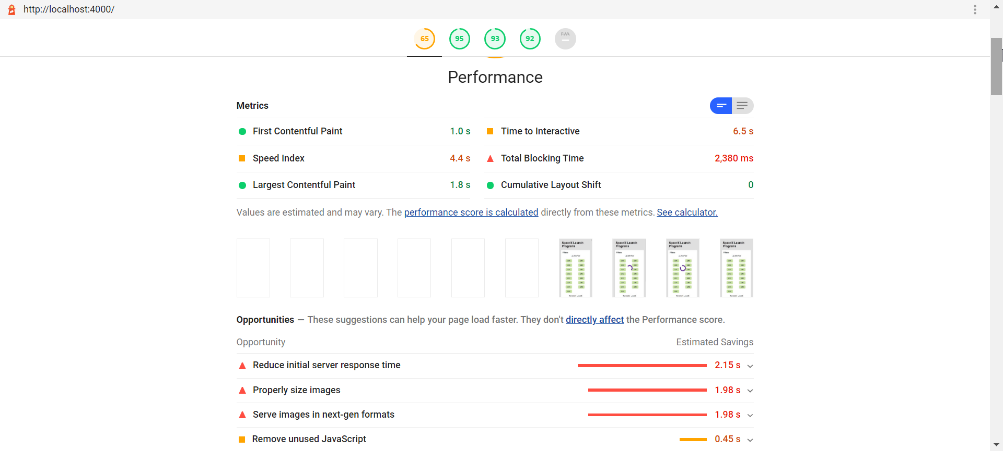

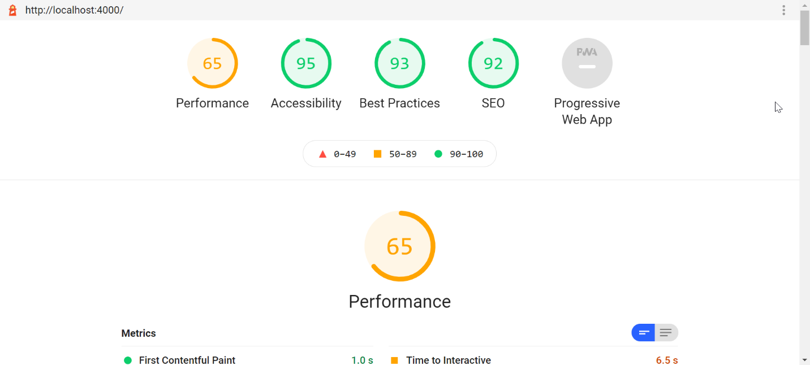

**Reason for Low performance score:** One of the main reasons for having low score in Performance index, is the time taken by the API to send the response. Google Lighthouse consider, the API response time < 1ms is good whereas this API takes 2-3 second to return 100 records.

Apart from the API timing, currently backend sends image in PNG format which takes more time to load in the UI. I have used “loading: lazy” attribute in my code to prevent loading all the images at once but still it takes time to load all the images in the viewport.

There were other issues as well, I tried to fix as much as possible but as mentioned to me due to the time constrain, I was not able to fix all of the issues.

Apart from the performance index, other indices are significantly better in the lighthouse score.